Pediatric Colorectal Problems Nursing Workshop

A Comprehensive Surgical and Bowel Management Workshop for Nurses and Nurse Practitioners

March 16-18, 2015
Cincinnati Children’s Hospital Medical Center
3333 Burnet Avenue
Cincinnati, Ohio 45229

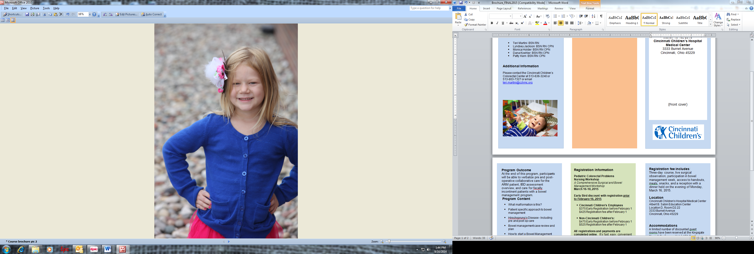

(Front cover)
Accreditation

Nursing contact hours will be awarded to nurses who attend the entire program and complete an evaluation.

Cincinnati Children’s Hospital Medical Center (OH-046, 9/1/2015) is an approved provider of continuing nursing education by the Ohio Nurses Association (OBN-001-91), an accredited approver by the American Nurses Credentialing Center’s Commission on Accreditation.

Course Directors

- Teri Martini BSN RN
- Lyndsey Jackson BSN RN CPN
- Monica Holder BSN RN CPN
- Dana Koehler BSN RN CPN
- Patty Kern BSN RN CPN

Additional Information

Please contact the Cincinnati Children’s Colorectal Center at 513-636-3240 or
513-803-7327 or email teri.martini@cchmc.org




Program Outcome
At the end of this program, participants will be able to verbalize pre and post-operative collaborative care for the ARM patient, IBD assessment overview, and care for fecally incontinent patients with a bowel management program.
Program Content

- What malformation is this?
- Patient specific approach to bowel management
- Hirschsprung’s Disease - Including pre and post op care
- Bowel management case review and plan
- How to start a Bowel Management Program
- Surgical demonstration - Posterior Sagittal Anorectoplasty
- Pre and post operative care of the colorectal patient
- Gynecology concerns in the colorectal patient
- Urinary testing/ management
- Multidisciplinary approach to the ARM patient
- Inflammatory Bowel Disease

Program Schedule
Monday, Tuesday and Wednesday
7:30 Registration/Breakfast
8:00 Program
11:00 Lunch
12:00 Program/Surgical demo(Tuesday)
4:00 Adjournment /Evaluations
Registration fee includes:
Three-day course, live surgical observation, participation in bowel management week, access to handouts,
meals, snacks, and a welcome reception with dinner held on the evening of Monday, March 16, 2015.

Location
Cincinnati Children’s Hospital Medical Center
Albert B. Sabin Education Center
Location D, Room D2.22
3333 Burnet Avenue
Cincinnati, Ohio 45229

Accommodations
A limited number of discounted guest
rooms have been reserved at the Kingsgate Marriott Conference Hotel, 151 Goodman Avenue, Cincinnati, OH 45229 for March 15, 16, 17, and 18. Room rates are $135/night plus tax.

To reserve a guest room, please call the Kingsgate Marriott at 1-800-228-9290 or 513-487-3800 on or before February 23, 2015 (reservations deadline) .
Please identify yourself as part of the Pediatric Colorectal Problems Nursing Workshop sponsored by Cincinnati Children’s.
Registration Information

Pediatric Colorectal Problems
Nursing Workshop
A Comprehensive Surgical and Bowel Management Workshop
March 16-18, 2015

Early Bird discount with registration prior to February 16, 2015

- Cincinnati Children’s Employees
$375 Early Registration before February 1
$425 Registration fee after February 1

- Non-Cincinnati Children’s:
$475 Early Registration before February 1
$525 Registration fee after February 1

All registrations and payments are completed online. It’s fast, easy, convenient and secure! Each registrant must use a unique email address to register. Go to:

http://tinyurl.com/kknmgxj

Please note: Credit card payments will be processed at the time of online registration. If registering from outside the U.S., please notify your bank/credit card company of this transaction to facilitate processing.

We accept the following types of payment online:
- Visa or MasterCard
- Electronic Check – no more writing checks and mailing them in. With eCheck you can pay using your checking account online. It’s safe and secure! Select the first option “Online Credit Card Payment or Electronic Check Payment” and follow the onscreen directions.
- Please reserve your spot early.

Please note: Credit card payments will be processed at the time of online registration. If registering from outside the US, please notify your bank/credit card company

