Closed Captioning in Zoom
HOST:
- When the Host starts the Zoom, verify that Closed Captioning is enabled. If Closed Captioning is not on the tool bar, click the “…More” button
- Click “Captions”
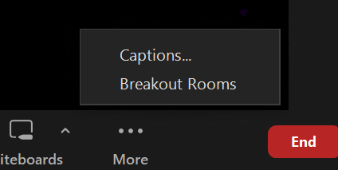

- “Enable Captions” (if not already enabled)
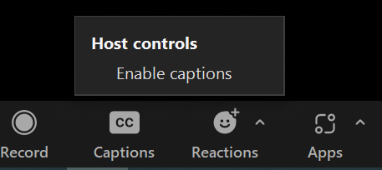

Zoom Attendee:
- For a Zoom attendee to view Closed Captioning, they can click “Captions” in the toolbar, or “…More” if the “Captions” button is not in the toolbar.

- The attendee can click “Captions” > “Show Captions”
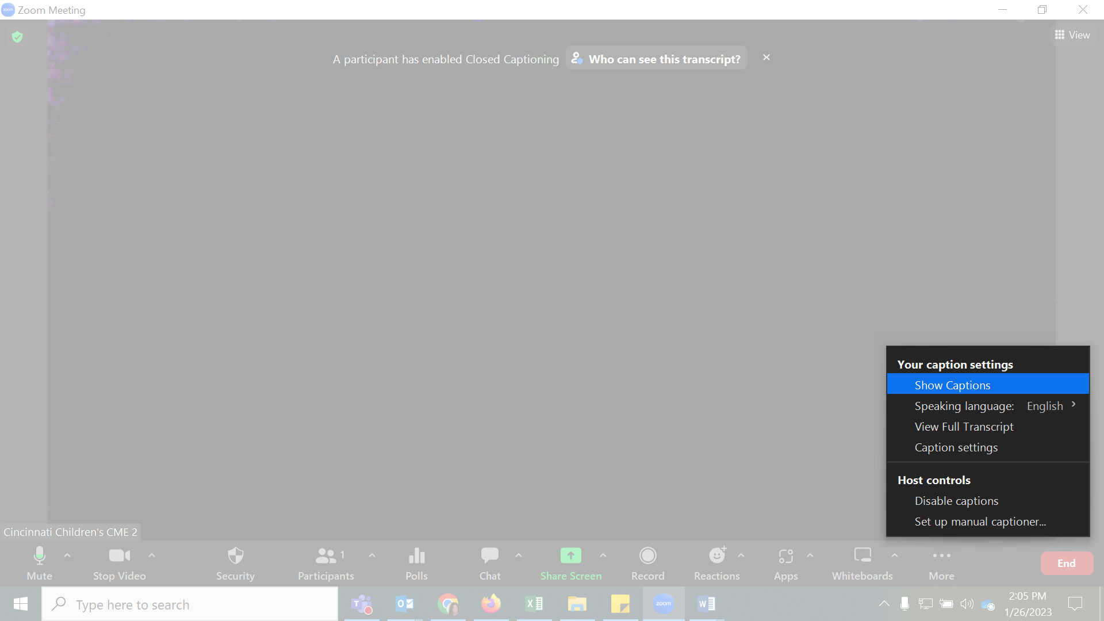
- The attendee will then select what language they want to see the Closed Captioning in and click “Save” the Closed Captioning will then be viewable to the attendee
