How to run an Attendee Report in Zoom
- Log into Zoom
- Click “Reports”
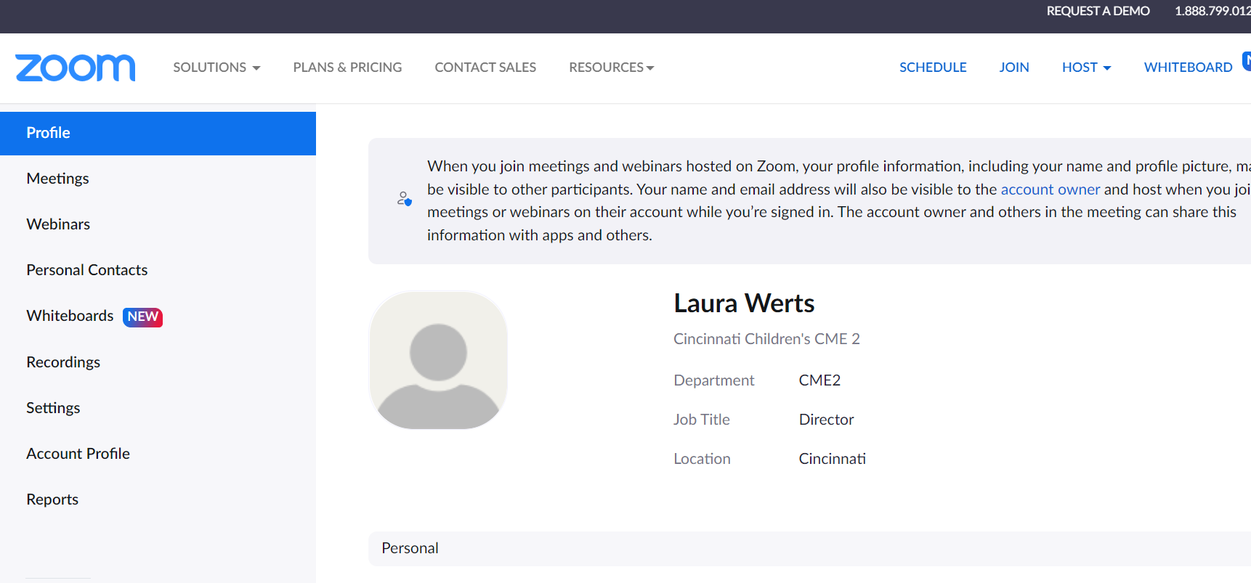

- Click Usage
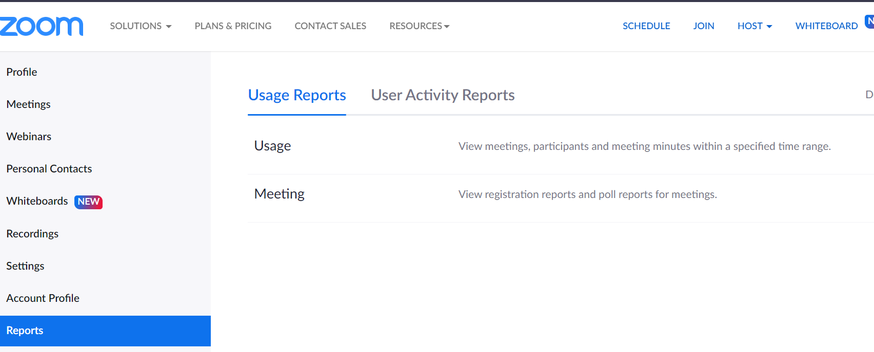

- You can then filter by date for the meeting
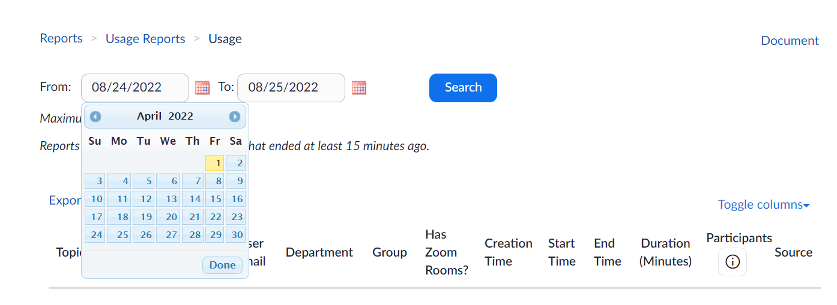

- Click Search
- Once you find the meeting you want to run attendance for, you will need to scroll the way to the right
- Click on the “Participants Number” hyperlink for the meeting you wish to run the report for:

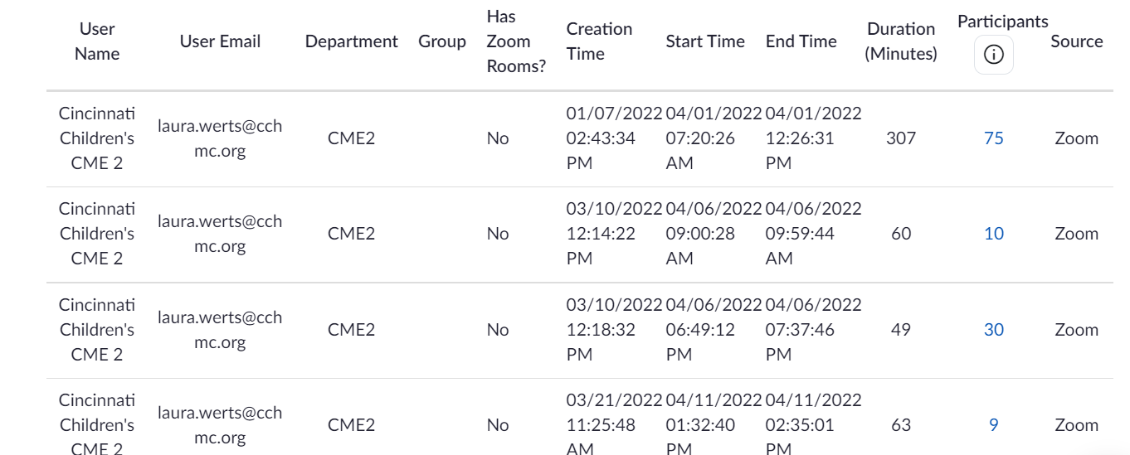

- Click “Export with Meeting Data”
- If you wish to show the times each user logged in and out of the meeting, do not click “Show Unique Users”. However, each person can show up multiple times in the report depending on how often they logged in and out. If you click “Show Unique Users” each person will only appear once on the report, and it gives a total duration of how long they were in the meeting

“Show Unique Users” not Checked:

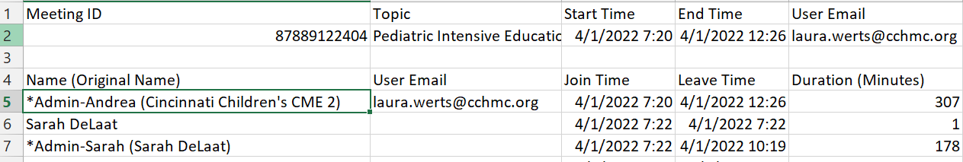

“Show Unique Users” Checked:
