Instructions

The easiest way to do this is for users to install an addon called [Video DownloadHelper](https://chrome.google.com/webstore/detail/video-downloadhelper/lmjnegcaeklhafolokijcfjliaokphfk)  This addon is available for both firefox ([Firefox VideoDownloadHelper](https://addons.mozilla.org/en-US/firefox/addon/video-downloadhelper/)) and google chrome ([Chrome VideoDownloadHelper](https://chrome.google.com/webstore/detail/video-downloadhelper/lmjnegcaeklhafolokijcfjliaokphfk)).

**How to Include a Video in a PowerPoint Presentation**

By Steve McDonnell

3 minutes

**Step 1**

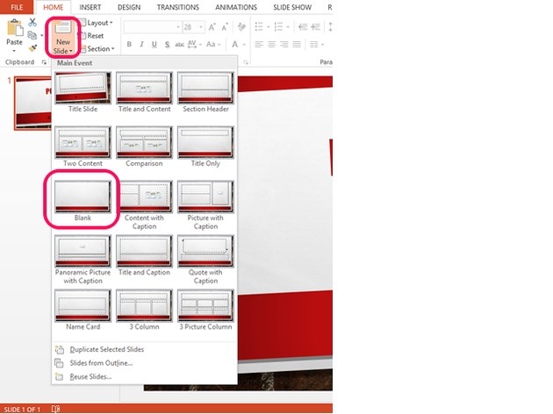

Image Credit: Steve McDonnell/Demand Media

Add a blank slide to the presentation.

**Step 2**

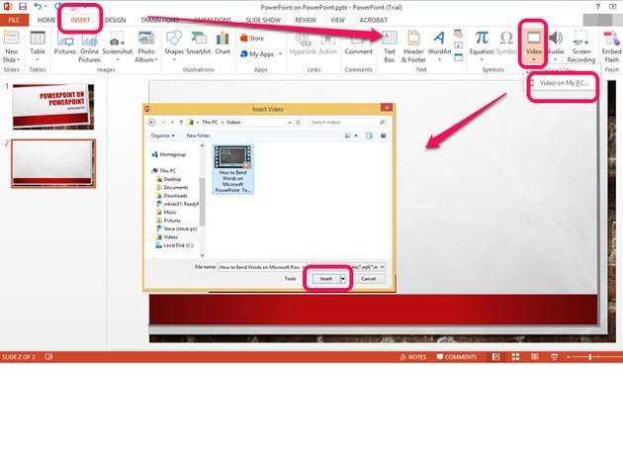

Image Credit: Steve McDonnell/Demand Media

Choose **Insert** from the menu. Select **Video** from the ribbon bar and choose **Video on my PC...** Then, navigate to the location where the file is stored and click the video to highlight and select it.

**Step 3**

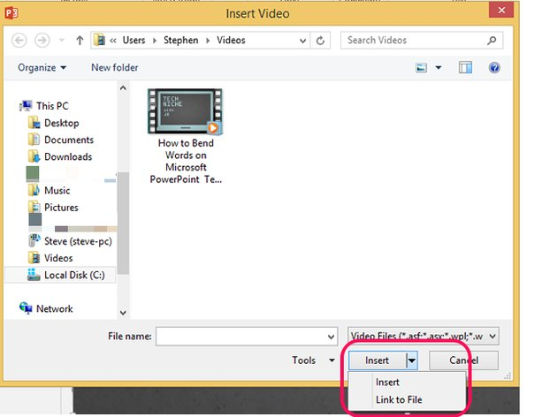

Image Credit: Steve McDonnell/Demand Media

Select **Insert** and then choose one of the following two options to include the video:

**Insert:** PowerPoint inserts the video file into the PowerPoint presentation and it becomes part of the PowerPoint document. You can copy the PowerPoint presentation to a different computer and the video will still play. However, if you modify the video, you must reinsert it into your presentation to update it with any changes.

**Warning**

Inserting the video results in a much larger PowerPoint presentation file than linking.

**Link to File:** PowerPoint plays the video file on your computer from the location where it resides when you add the link. If you move the video file to a different location on your computer or if you copy the PowerPoint presentation to a different computer, the video won't play. However, if you modify the video and don't change the location, your presentation will always play the most recent version.

**Tip**

Linking to the video results in a smaller PowerPoint presentation file than inserting.

**Step 4**

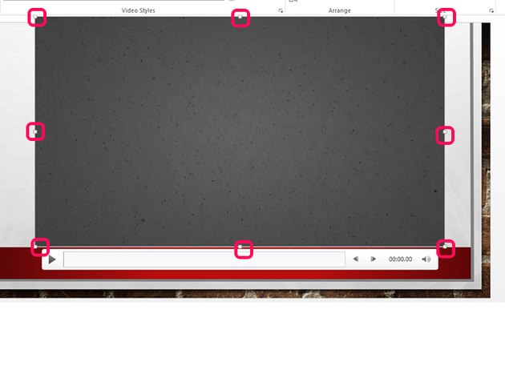

Image Credit: Steve McDonnell/Demand Media

Use the bounding boxes to resize the video to fit on your slide within your presentation theme.

**Step 5**

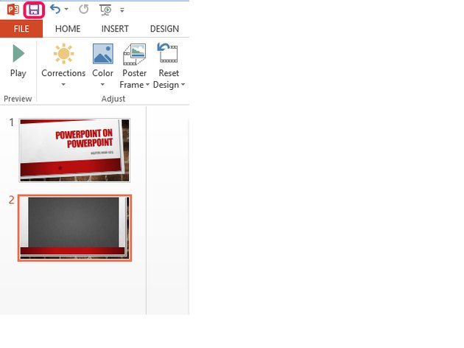

Image Credit: Steve McDonnell/Demand Media

Click or tap the **Save** icon to save your presentation.

**Tip**

If you inserted a video into your presentation, choose **File** from the menu to view the Info screen with information about your presentation. Consider selecting the **Compress Media** option to reduce the size of the video files you inserted into the PowerPoint presentation and [improve](https://support.office.com/en-us/article/Tips-for-improving-audio-and-video-playback-and-compatibility-ca756be4-301e-4161-a48c-b7d72c6e1d8d) playback performance. Choose **Presentation Quality** to shrink the size of the file without saving