TEXT REGISTRATION
Returning users advance to Step 2
*You must have an existing CloudCME profile. To create a profile visit https://cchmc.cloud-cme.com
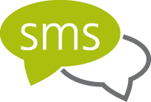  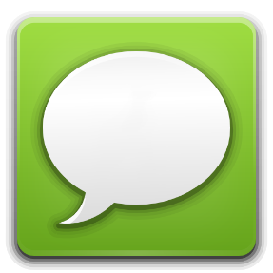 | Step 1  - Text (513) 409-9506 your CME profile email address  - Receive reply text: “Thank you [Your Name], your phone number has been updated to [Your Cell Number]”  - NOTE: If reply text does not state [Your Name] you did not text your profile email address. Re-text a different email address  Step 2  - Text (513) 409-9506 today’s unique 5-digit activity code located by the entrance  - Receive reply text: “Thank you [Your Name] we have recorded your attendance for [Today’s Activity]”  - NOTE: If you do not receive a reply text, your CME transcript will not document today’s activity participation

